APPENDIX 5

GUIDANCE NOTE
ON
THE SELECTION OF AND SAFE USE OF
PORTABLE COMPUTERS

1. Portable Display Screen Equipment

This guidance relates to Portable Display Screen Equipment (DSE), such as laptop, notebook computers and portable digital assistants (PDA’s). Like desk top equipment, portable DSE is subject to the DSE Regulations if it is in prolonged use.

Increasing numbers of staff and students are using portable DSE as part of their work. While research suggests that some aspects of using portable DSE are no worse than using full sized equipment that is not true of every aspect. The design of portable DSE can include features (such as smaller keyboards or a lack of keyboard/screen separation), which may make it more difficult to achieve a comfortable working posture. Portable DSE is also used in a wider range of environments, some of which may be poorly suited to DSE work.

To reduce risk to portable DSE users, the following recommendations should be followed in addition to the general advice provided regarding DSE.

2. Risk assessment

Risk assessment for users of portables can be a challenge, as it is clearly not practicable to avail of the expertise of a DSE Assessor to analyse each location where work may take place as a user travels around with their portable.

By providing portable DSE, users with sufficient training and information (such as this guidance) should enable the user to carry out their own risk assessment and ensure that measures are taken to control risks (for example poor posture) whenever they set up their portable. Portable users’ risk assessments for, say, half an hour’s work in a borrowed office can be quite informal and need not be written down. Where, however, a portable is in lengthy or repeated use in the same location, it would be appropriate for the University DSE workstation assessment process to be implemented. In all cases, portable users need to be alert to potential risks and report any problems to their DSE Assessor, line manager, Department Safety Officer or Trade Union Safety Representative.

As well as the risks common to both portables and desktop DSE work, the following additional risks may be associated specifically with portable DSE work and need to be taken into account by managers and users:

Manual handling risks when moving between locations (bearing in mind that other equipment such as spare batteries, printers, or papers may add to the burden of the portable itself)

a) Risk of theft possibly involving an assault.

b) Points to look for in choosing equipment and designing tasks to minimise risks are discussed in section 3.

3. Equipment, workstation and task requirements

As with full-sized DSE, portables in prolonged use (and the workstations and working environments where they are used) are required to comply with the minimum requirements for DSE (see appendix 2 of the University’s Code of Practice and Guidance for DSE). The main difference is that the inherent requirements of portability may mean that some of the detailed requirements of the schedule cannot be complied with in all respects.

Users and managers should be aware that some design compromises inherent in portables could lead to postural or other problems (for example a bent neck, or headaches arising from a low, fixed position of the screen). One way of tackling such risks is to avoid prolonged use and take more frequent breaks. Another way, if working in an office, is to use the portable with a docking station; more advice on this is given below.

Some particular points for management and users to consider when selecting portable computers are as follows:

(a) Look for as low a weight as possible (for example 3 kg or less) for the portable computer, and keep accessories as few and as light as possible.

(b) Choose as large and clear screen as possible that can be used comfortably for the task to be done.

(c) Where available, opt for a detachable or height adjustable screen.

(d) Specify as long a battery life as possible. Where practicable, provide extra transformer/cables set so the user has a set in each main location where the portable is used, and only carries the computer, not the transformers/cables etc.

(e) Give users a lightweight carrying case with handles and shoulder straps. To reduce risk of theft or assault, avoid manufacturer-branded laptop cases.

(f) Look for tilt adjustable keyboards on laptops.

(g) Choose a portable capable of being used with a docking station and/or with a facility for attaching an external mouse, keyboard and/or numeric keypads, where these are likely to help the user to work comfortably.

(h) Check the portable has friction pads underneath to prevent it sliding across work surfaces when in use.

(i) To cut working time and user stress, ensure the portable has sufficient memory and speed for the applications to be used.

(j) For some tasks it may also be desirable to provide add-ons that improve usability and reduce maintenance time, such as (removable) CD-ROM drives and additional memory – but consider the weight penalty when deciding if these are appropriate.

(k) For applications requiring use of a non–keyboard input device, opt for a portable with a touch pad, roller ball or external mouse rather than a “nipple” trackpoint or isometric joystick device.

(l) Many users find it more comfortable to use portables whose casing includes a space (wrist pad) between the keyboard and the front edge.

Points for management and users to consider when planning tasks involving portable computers are:

(a) Think about weights to be carried. Where necessary (for example if staff are carrying substantial amounts of other equipment and/or papers), carry out a manual handling risk assessment in conjunction with portable the computer user.

(b) set up the portable on a suitable work surface wherever possible, and avoid use for extended periods in other situations. For example resting a portable on the user’s lap is not only likely to induce a poor working posture but could result in discomfort due to the heat generated by the computer.

(c) Provide docking stations or similar equipment (see below) at workstations where portable computers will be in lengthy or repeated use.

(d) Use portable computers only when away from the main place of work, or when docking station equipment is unavailable.

(e) Minimise the use of portable computers in non-ideal locations such as motor vehicles.

(f) Ensure that handheld computers for prolonged use are carefully selected for ergonomic features, which match the requirements of the tasks undertaken. For example equipment to be used outdoors should be adequately waterproof, legible in bright sunlight, and keyboards and screens should be large enough to be used comfortably.

Docking stations are a way to avoid many of the ergonomic disadvantages of portables by allowing the use of a full size screen and/or keyboard (mouse or other peripherals). Designs vary: some resemble a full sized PC with a slot for a portable instead; others comprise a screen, keyboard, mouse and/or other peripherals connected to the portable by cables or wireless links. There are also systems that provide a full-sized keyboard plus raiser blocks to enable the portable’s own screen to be viewed at a more convenient height (see figure 1).

Height-adjustable stands for notebook computers are also available. In setting up any kind of docking station, the aim is for the user to achieve a comfortable working position allowing some variation in posture and having sufficient space for documents and anything else needed for their work task.
The general advice on workstations and work environments in appendix 2 of the University code of practice should be followed, treating the docking station in the same way as full-sized DSE.

Figure 1 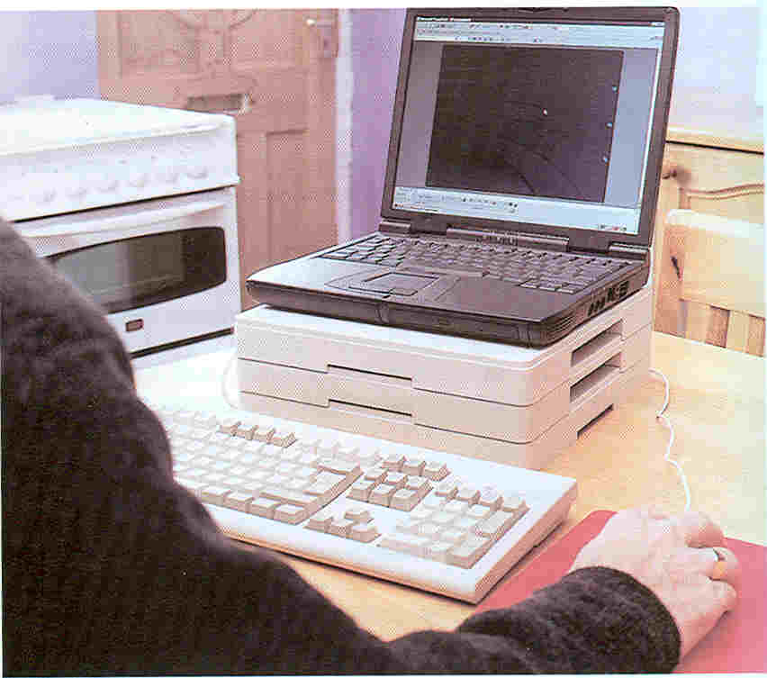
*Source Work with Display Screen Equipment, Guidance on Regulations, L26, HSE Books

A risk of theft or mugging exists in some circumstances. They can be tackled by a combination of user training and task design; for example:

(a) Designing tasks in such a way that lone users are not expected to carry or use portables in circumstances where theft is likely.

(b) Users taking sensible precautions such as not carrying portables in luggage with a computer manufacturer’s branding; not leaving or using a portable in a parked car; and taking extra care in public places, or in other situations (or at times) where the risk of theft may be greater.

If the task involves risk from manual handling, managers and users can take commonsense steps to cut down the risk; for example:

(a) Do not carry equipment or papers unless they are really likely to be needed.

(b) Consider using a backpack to cut down strain on arms and distribute loads evenly across the body (or wheeled luggage might be worth considering)

(c) Remember you may be able to avoid carrying heavy papers by sending then in advance, by post or e-mail, to your destination or storing them electronically on the portable or on a disk.

Breaks or change in activity

Breaks or change in activity are particularly important for portable users not working at a docking station. Such users need longer and more frequent breaks or change in activity to compensate for poorer working environments, which can impact particularly on posture.
Staff who use portable DSE equipment, particularly those who travel and work unsupervised, should take breaks frequently. Line management / supervision should ensure that they are reminded of this.

4. Eyes and eyesight

With regard to eyes and eyesight, there are few special considerations for portable DSE users, although it may be helpful for the user to tell the optician doing any eye test that a portable is used, as typical viewing distances may be somewhat shorter than for a desktop DSE.

5. Information and Training

Health and Safety information / training is particularly important for those staff who undertake any prolonged use of portables. Management should ensure such staff have received training and information, including the following issues specific to using portables:

(a) Advice on how to set up and use the equipment in the locations where it is to be used (bearing in mind the user needs sufficient knowledge of risk and precautions to, in effect, re-do the risk assessment whenever starting work in each location; as discussed in section 2.)

(b) Guidance on starting up and using a docking station, and additional precautions if using a portable computer when a docking station is not available (see figure 2 below which shows a setup that would not be acceptable for extended use.)
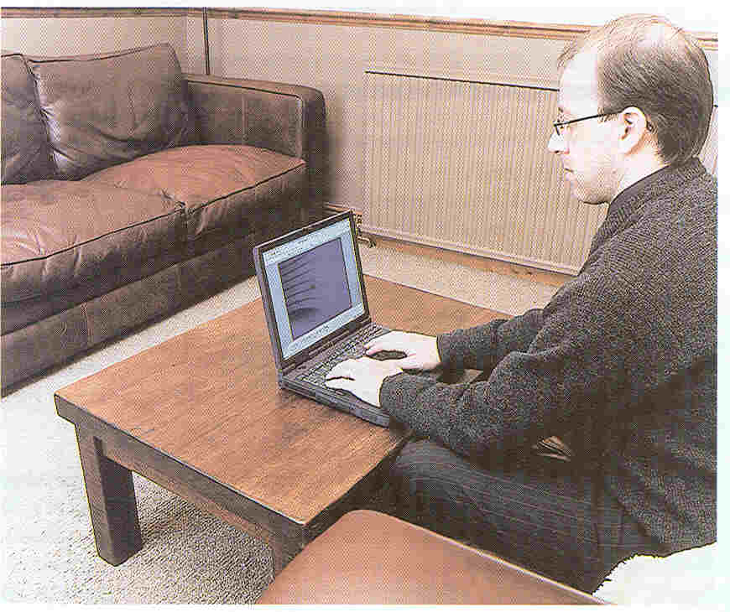
Figure 2
*Source Work with Display Screen Equipment, Guidance on Regulations, L26, HSE Books
(c) Encouragement and advice on how to report promptly any symptoms of discomfort that may be associated with their use of portables DSE, and where to get further advice and help.

(d) A reminder to take regular breaks; bearing in mind that increased DSE use is linked to an increasing risk of discomfort.

(e) How to avoid unnecessary manual handling when carrying around portable DSE (and associated equipment and/or paperwork), and how to reduce risk from such manual handling as is unavoidable.

(f) Advice on how to minimise risks of theft and mugging.

Managers of staff who use portable DSE should avail themselves of the health and safety information and training provided, so that they are aware of the issues and able to take action to prevent health risk and respond to any problems reported.

Key issues managers should be aware of are:

(a) The need for regular breaks to avoid unnecessary use of DSE for extended periods.
(b) Benefits of ensuring adequate variety in users’ tasks.
(c) Importance of health and safety training for users.
(d) Reasons for providing docking stations equipment wherever possible, and encouraging its use.

